**Project Documentation: Hotel Booking Data Analysis**

**1. Introduction**

**1.1 Overview**

The **Hotel Booking Data Analysis** project aims to analyze hotel booking data to uncover actionable insights that can improve revenue, optimize operational efficiency, and enhance customer satisfaction. By leveraging data-driven decision-making, the project helps stakeholders identify trends, segment customers, and implement strategies to maximize profitability and reduce costs.

**1.2 Purpose and Significance**

* **Purpose**: To analyze hotel booking data to identify patterns, trends, and opportunities for improving revenue, reducing operational costs, and enhancing customer experience.
* **Significance**: The hospitality industry is highly competitive, and data-driven insights are critical for staying ahead. This project helps hotel management make informed decisions to improve revenue, reduce cancellations, and enhance customer experience.

**1.3 Scope**

* **Data Scope**: The analysis covers hotel bookings, including customer demographics, booking channels, room types, meal plans, and cancellation trends.
* **Functional Scope**: Development of a Power BI dashboard to visualize key metrics and trends.
* **Geographical Scope**: Focus on international bookings, with a breakdown by country.
* **Time Scope**: Analysis of booking trends over time, including seasonality and lead time.
* **Stakeholders**: Hotel management, marketing teams, operations teams, and business analysts.

**1.4 Stakeholders**

* **Hotel Management**: To make data-driven decisions for revenue optimization and operational efficiency.
* **Marketing Team**: To design targeted campaigns based on customer segmentation and booking trends.
* **Operations Team**: To improve resource allocation and reduce operational costs.
* **Customers**: To benefit from improved services, pricing strategies, and loyalty programs.

**2. Project Objectives**

**2.1 Problem Statements**

* **Revenue Optimization**: How can the hotel maximize revenue by understanding booking patterns, customer preferences & demographics and pricing strategies?
* **Cancellation Management**: What are the key drivers of cancellations, and how can they be reduced?
* **Operational Efficiency**: How can the hotel improve resource allocation and reduce operational costs?
* **Customer Satisfaction**: How can the hotel enhance customer experience and increase repeat bookings?

**2.2 Key Goals**

* **Revenue Optimization**: Increase total revenue by identifying high-revenue segments and optimizing pricing strategies.
* **Customer Retention**: Improve customer loyalty and repeat bookings through targeted marketing and loyalty programs.
* **Operational Efficiency**: Reduce operational costs by optimizing resource allocation and improving room utilization.
* **Cancellation Reduction**: Minimize cancellations and no-shows through better policies and customer engagement.

**3. Data Sources & Preparation**

**3.1 Description of Datasets**

* **Dataset**: Hotel booking data containing information on bookings, cancellations, customer demographics, room types, meal plans, and booking channels.
* **Key Variables**:
  + hotel: Type of hotel (Resort Hotel or City Hotel).
  + is_canceled: Whether the booking was canceled.
  + lead_time: Number of days between booking and arrival.
  + arrival_date_year, arrival_date_month: Date of arrival.
  + adults, children, babies: Number of guests.
  + country: Country of origin.
  + market_segment: Booking channel (e.g., Online TA, Direct).
  + distribution_channel: Distribution method (e.g., TA/TO, Corporate).
  + customer_type: Type of customer (e.g., Transient, Contract).
  + adr: Average Daily Rate.
  + total_of_special_requests: Number of special requests.

**3.2 Data Sources**

* **Primary Source**: Hotel booking dataset (CSV file).
* **Secondary Sources**: External data on market trends, competitor pricing, and customer preferences.

**3.3 Data Preparation**

* **Data Cleaning**: Handled missing values, removed duplicates, and corrected inconsistencies.
* **Data Transformation**: Created new variables (e.g., total revenue, length of stay) and aggregated data for analysis.
* **Data Validation**: Ensured data accuracy by cross-checking calculations and validating against external benchmarks.

**4. Methodology and Approach**

**4.1 Implementation Framework**

* **Tools Used**: Power BI for dashboard creation, SQL for data cleaning and analysis.
* **Framework**: CRISP-DM (Cross-Industry Standard Process for Data Mining).

**4.2 Methods Applied**

* **Descriptive Analysis**: Summarized key metrics (e.g., total revenue, ADR, occupancy rate).
* **Segmentation Analysis**: Grouped customers by demographics, booking channels, and room types.
* **Trend Analysis**: Analyzed revenue and booking trends over time.
* **Predictive Analysis**: Identified factors influencing cancellations and revenue.

**4.3 Assumptions and Limitations**

* **Assumptions**:
  + All bookings are independent events.
  + Cancellations are primarily influenced by lead time and booking channel.
* **Limitations**:
  + Limited data on customer feedback and satisfaction.
  + External factors (e.g., economic conditions, competitor actions) are not included.

**5. Dashboard Design & Features**

**5.1 Key Metrics**

* **Total Revenue**: $43M.
* **ADR (Average Daily Rate)**: $102.
* **Occupancy Rate**: 65%.
* **Cancellation Rate**: 30%.
* **Repeat Guest Percentage**: 10%.

**5.2 Visualizations**

* **Revenue Trends**: Line chart showing monthly revenue.
* **Customer Segmentation**: Pie charts and bar charts for customer type, country, and market segment.
* **Room Utilization**: Heatmap showing revenue by room type.
* **Cancellation Analysis**: Bar chart showing cancellation rates by lead time and booking channel.

**5.3 Filters**

* **Hotel Type**: Resort Hotel vs. City Hotel.
* **Market Segment**: Online TA, Direct, Corporate, etc.
* **Country**: Top revenue-generating countries.
* **Time Period**: Monthly, quarterly, or yearly trends.

**Dashboard Preview:**

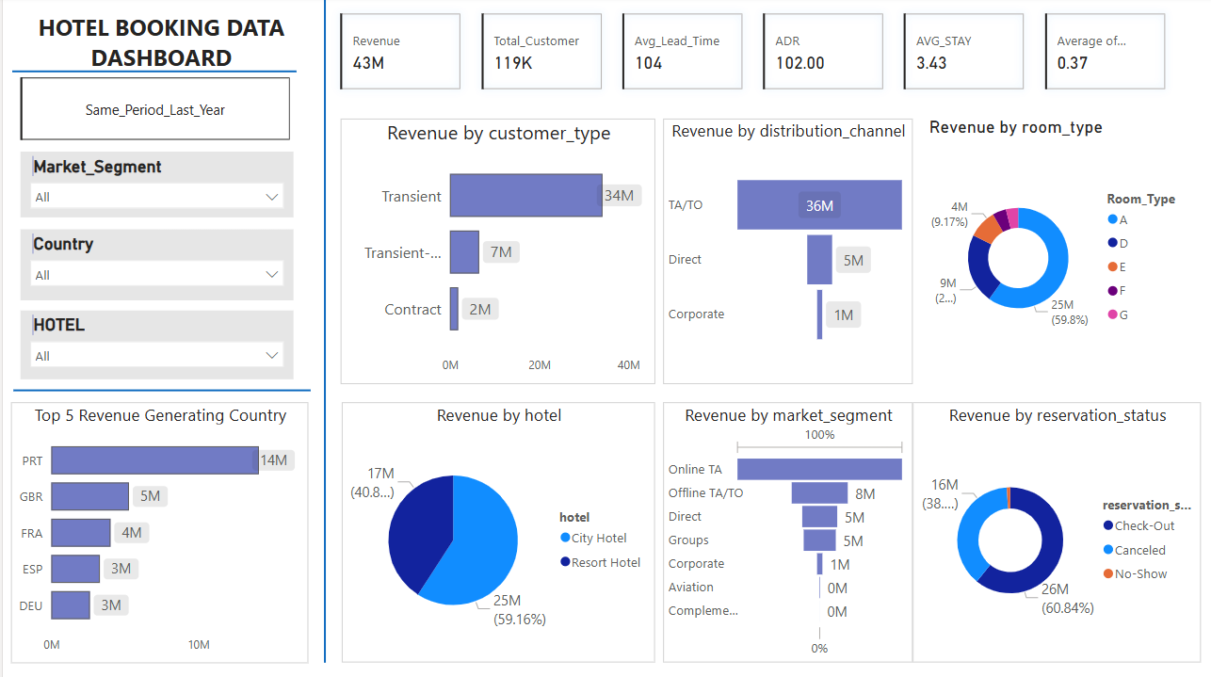

Revenue Analysis

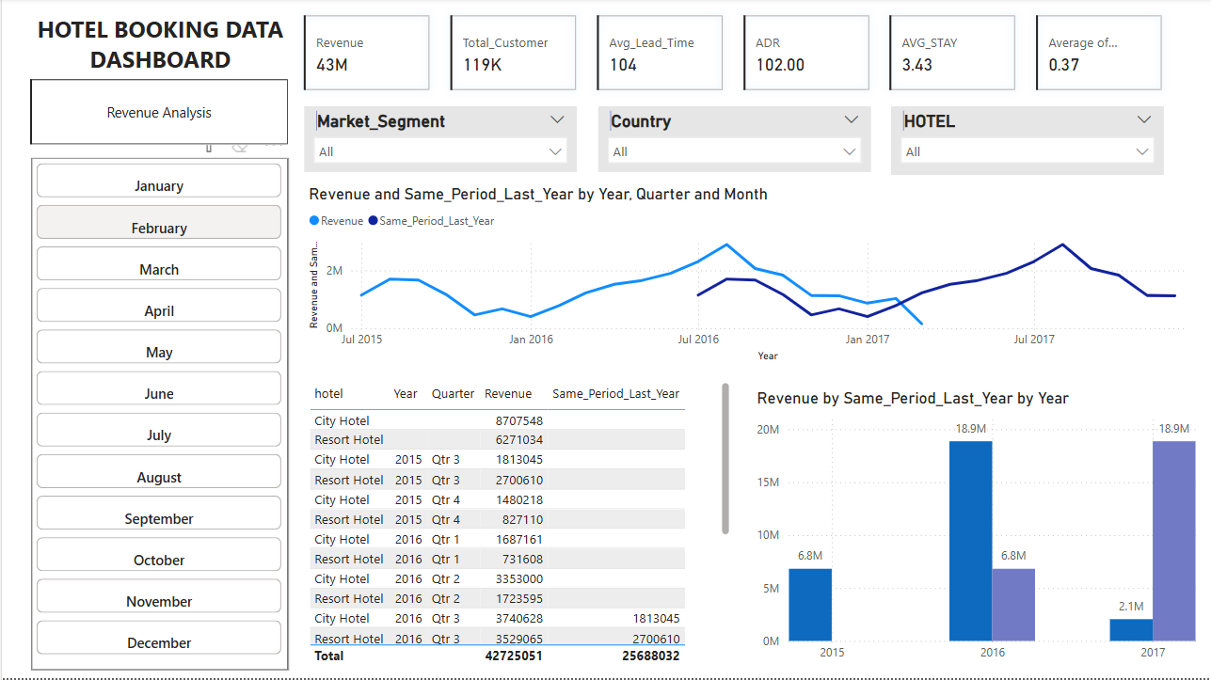

Same Period Last Year Analysis

**6. Insights & Analysis**

**6.1 Revenue Performance & Trends**

* **Total Revenue**: $43M, with 119K customers.
* **ADR**: $102, indicating strong revenue per room.
* **Seasonal Trends**: Revenue peaks during summer and holiday seasons.

**6.2 Customer Segmentation**

* **Transient Customers**: Contribute $34M, the highest revenue segment.
* **Corporate Customers**: Contribute only $2M, indicating a need for targeted marketing.

**6.3 Booking Channels**

* **TA/TO**: Contribute $36M, but high commission costs.
* **Direct Bookings**: Underutilized, suggesting a need for incentives.

**6.4 Hotel Performance**

* **City Hotels**: Generate 25M, higher than Resort Hotels (17M).
* **Room Type A**: Contributes 60% of revenue, while other room types are underutilized.

**6.5 Cancellation Impact**

* **Revenue Lost**: $16M due to cancellations and no-shows.
* **Cancellation Rate**: 30%, highlighting the need for better policies.

**6.6 Key Findings**

* **Revenue Insights**: Online TA contributes the highest revenue, while Corporate bookings have the highest ADR.
* **Cancellation Insights**: Cancellations are highest for bookings with long lead times and no deposit.
* **Occupancy Insights**: Occupancy rates peak during summer months, with underutilized room types during off-peak seasons.
* **Customer Insights**: Repeat guests contribute significantly to revenue, and special requests positively impact satisfaction.

**6.7 Business Insights**

* **Revenue Growth**: Focus on high-revenue segments (e.g., Online TA) and optimize pricing for Corporate bookings.
* **Cancellation Reduction**: Implement non-refundable deposits and incentives for early bookings.
* **Operational Efficiency**: Improve room utilization by offering discounts for underutilized room types during off-peak seasons.
* **Customer Satisfaction**: Enhance services for repeat guests and fulfill special requests to improve satisfaction.

**7. Challenges & Solutions**

**7.1 Challenges**

* **Data Quality**: Missing values and inconsistencies in the dataset.
* **High Cancellations**: Affecting revenue predictability.
* **Underutilized Room Types**: Low demand for certain room types.

**7.2 Solutions**

* **Data Cleaning**: Used SQL to handle missing values and inconsistencies.
* **Cancellation Policies**: Introduced non-refundable deposits and flexible rescheduling.
* **Room Type Optimization**: Adjusted pricing and marketing strategies for underutilized rooms.

**8. Conclusion & Future Enhancements**

**8.1 Conclusion**

The **Hotel Booking Data Analysis** project successfully identified key revenue drivers, customer segments, and operational inefficiencies. By implementing the recommended strategies, the hotel can increase revenue, reduce cancellations, and improve customer satisfaction.

**8.2 Future Enhancements**

* **Advanced Analytics**: Incorporate machine learning models to predict cancellations and optimize pricing.
* **Customer Feedback Analysis**: Include customer feedback data to enhance satisfaction insights.
* **Real-Time Dashboard**: Develop a real-time dashboard for live monitoring of bookings and revenue.
* **Real-Time Data Integration**: Incorporate real-time data for dynamic pricing and demand forecasting.
* **Mobile Dashboard**: Create a mobile-friendly version of the dashboard for on-the-go access